Steps:

- Install and open Eclipse Kepler and install Soot plugin.
- Open Example Project (MyMain.java)
- Run Soot
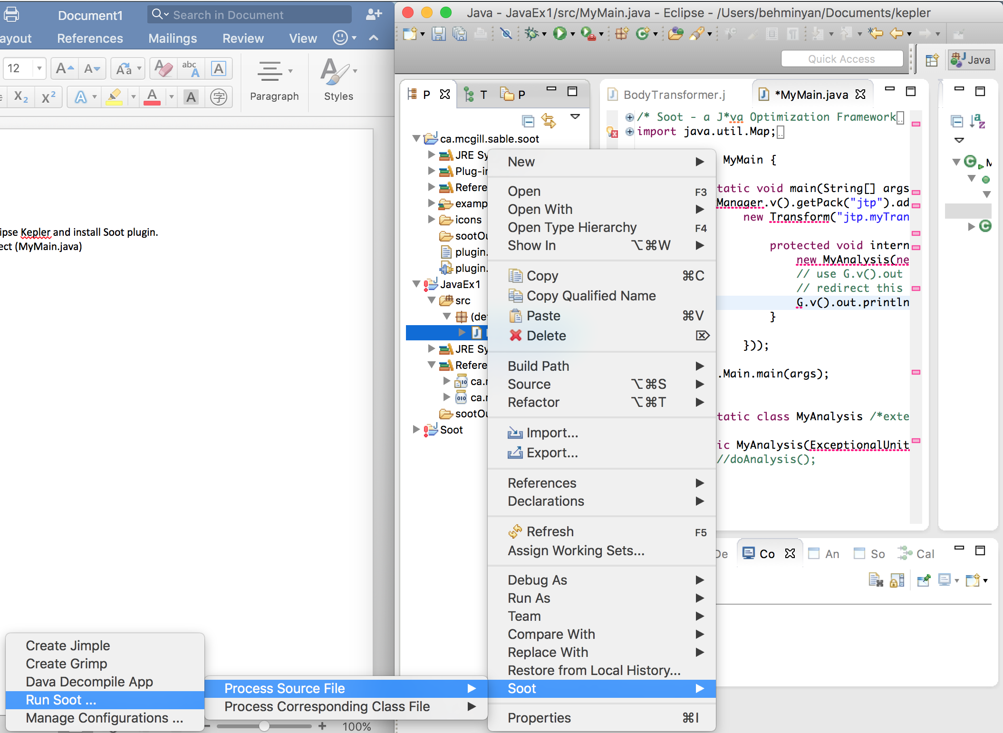

- Set Soot Launching Options (see appendix)
- Command appears on console:
Starting from Soot's class library:
soot.Main --p jap.npc only-array-ref:true --d /Users/behminyan/Documents/kepler/JavaEx1/sootOutput --src-prec java --outjar --cp /Library/Java/JavaVirtualMachines/jdk1.8.0_66.jdk/Contents/Home/jre/lib/ext/*.jar:/Library/Java/JavaVirtualMachines/jdk1.8.0_66.jdk/Contents/Home/jre/lib/*.jar:/Users/behminyan/Dropbox/2.2/IS470/eclipse/plugins/*.jar:/System/Library/Java/Extensions/MRJToolkit.jar:/Users/behminyan/Documents/kepler/JavaEx1/src/*.class --xml-attributes MyMain
- Nothing appears in sootOutput folder after waiting a few hours, and console looks the same. Screen looks like this (see next page)
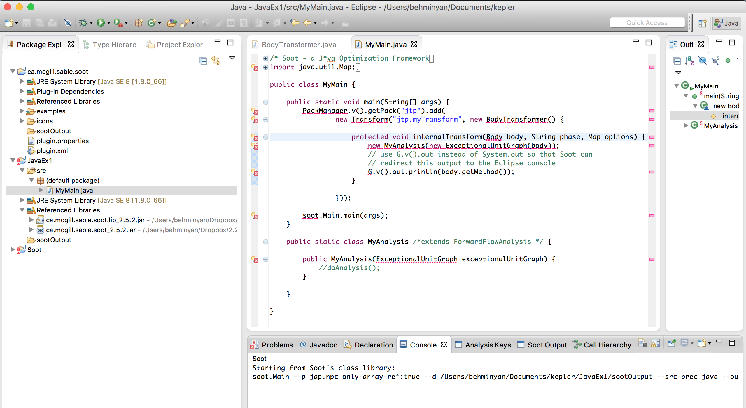

Appendix: Soot Launching Options

  - General Options: uncheck all (default)
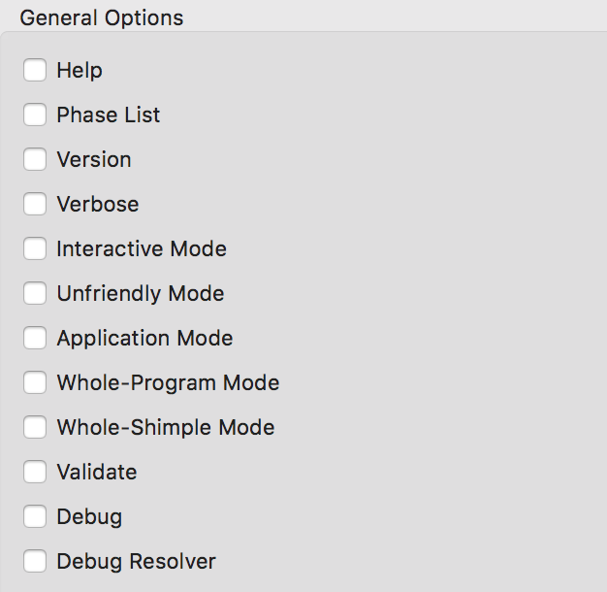
  - Input Source Precedence: Java File

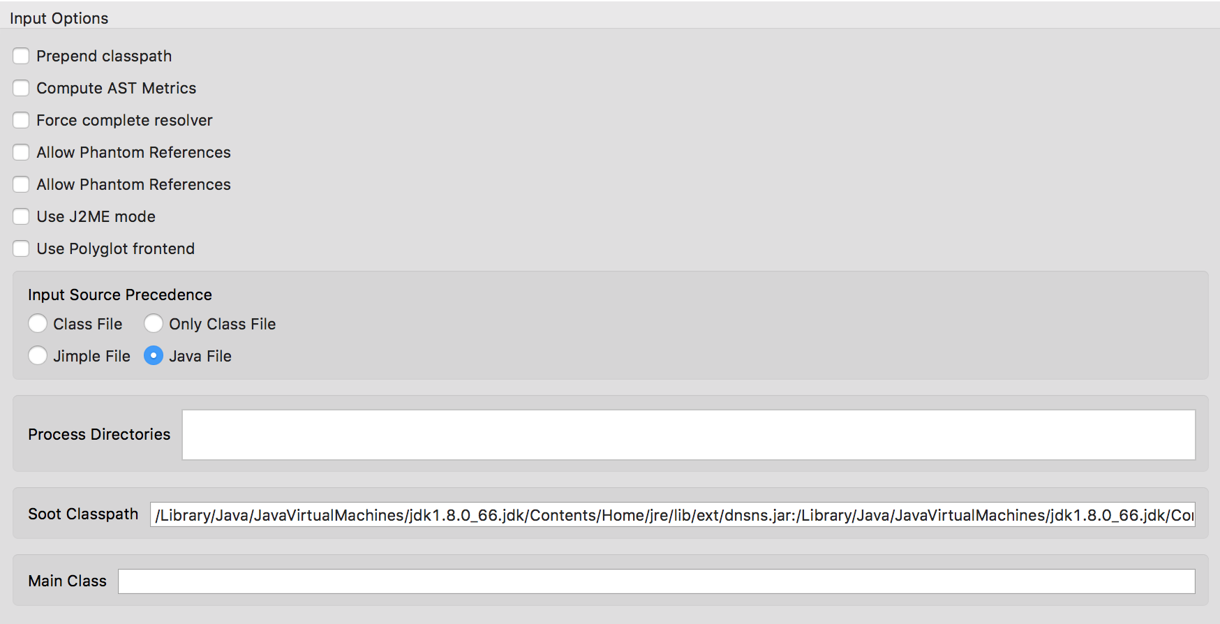

  - Output options: Jimple File. Output directory: sootOutput

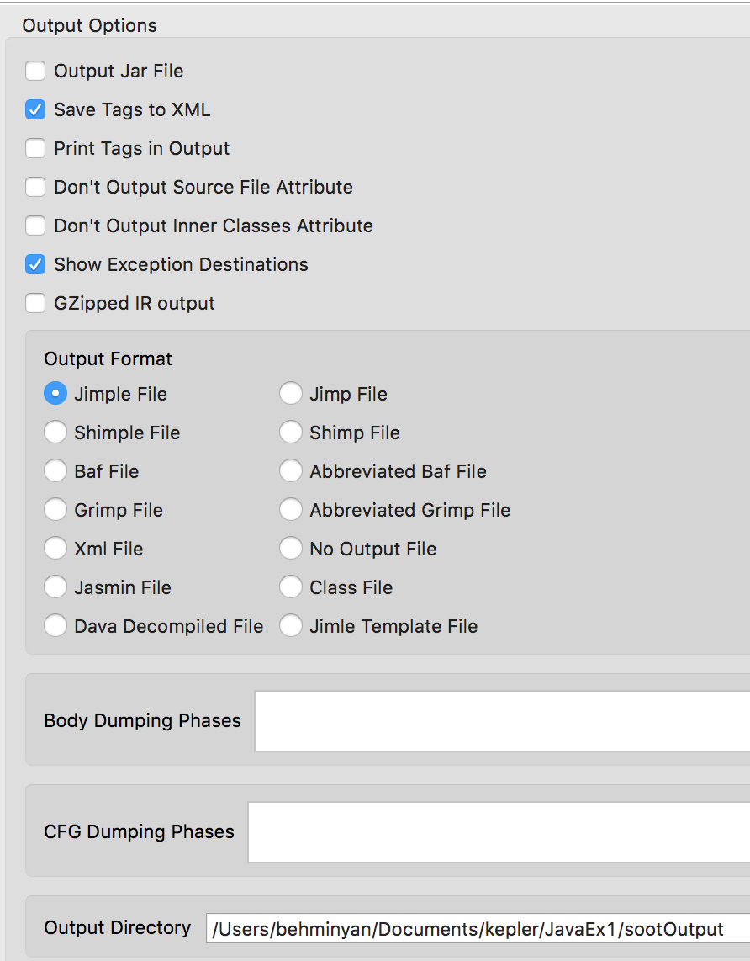
  - Annotation Options:
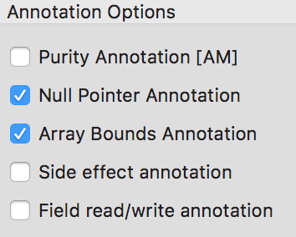

  - Enabled Jimple Annotation Pack
    - 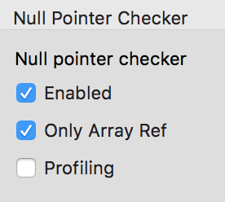
    - 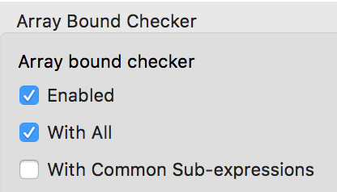

  - Soot Main Class Manager:
    - 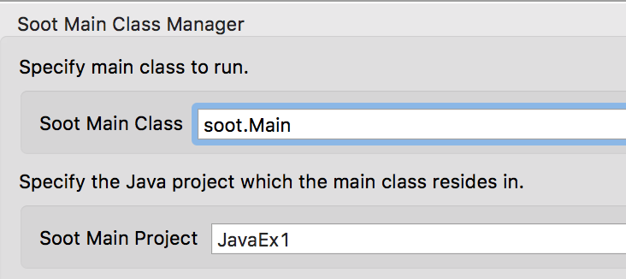

  - Left other options to default settings

